**East West University**

**Department of Computer Science and Engineering**

**CSE207 – Data Structures: LAB 02**

**Course Instructor: Ms. Tanni Mittra**

## **Linked List**

* Linked List is a sequence of links which contains items. Each link contains a connection to another link. Linked list is the second most-used data structure after array.

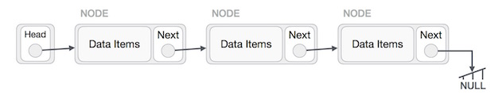

* Create a List ADT with the following operations.

|  |  |
| --- | --- |
| **Operation** | **Description** |
| 1. void add(int item) | add item to the end of the List |
| 1. void addbegin(int item) | Add item at the beginning of the list |
| 1. void addanypos(int pos, int item) | Add item at position pos in the List, moving the items originally in positions pos . |
| 1. bool contains(int item) | return **true** iff item is in the List |
| 1. int size() | return the number of items in the List |
| 1. bool isEmpty() | return true iff the List is empty |
| 1. int get(int pos) | return the item at position pos in the List (error if pos is less than 0 or greater than or equal to size()) |
| 1. int indexOf(int item) | Return position of the specified element in the list |
| 1. void removefirst() | Remove first element of the list |
| 1. void removelast() | Remove last element of the list |
| 1. void remove(int pos) | remove and return the item at position pos in the List |
| 1. void reverse() | Reverse the element of the list |
| 1. void sort() | Sort the element of the list in ascending order |